Air Export Pricing Engine
Sales and Pricing Team Guide

Document Version: 1.0
Target Audience: Commercial Pricing Managers, Sales Executives, Branch Managers, and Key Account Teams
Published: September 2026

1. What This Engine Is About
The Air Export Pricing Engine is an intelligent commercial assistant built to help our sales and pricing teams quote the most profitable, competitive sell rate for every air export inquiry.
In air freight forwarding, setting the right margin is always a delicate balancing act:
- Quote too high: we lose the shipment to competing forwarders or direct airlines, earning zero profit.
- Quote too low: we win the deal, but leave hard-earned money on the table, diluting branch profitability.
- Treat everyone the same: a 1-ton shipment for a top Key Account cannot be quoted with the same markup as a 10kg one-off parcel for an unknown walk-in customer.
This engine removes guesswork and manual pricing inconsistencies across branches. By analyzing thousands of our historical winning and lost quotes, it instantly calculates three things:
- The Market Benchmark Margin: what margin typically clears in the market for this specific route, cargo weight, and airline cost.
- The Win Probability: the realistic percentage chance that the customer will accept our quote at various price levels.
- The Recommended Commercial Quote: the exact sweet spot that maximizes our total expected rupee profit while protecting customer relationships.

2. How We Used Past Data
The engine was built using our company's historical inquiry and quote records. Raw commercial data is often noisy, containing test entries, duplicate quotes, and operational notes, so we put the data through a rigorous cleaning process before training the model.

A. How We Handled Duplicate Inquiries
In our daily business, a single customer inquiry often goes through several updates. A salesperson might create a preliminary draft, the customer may ask for a revised rate that creates a second or third revision, and the inquiry might go on hold before finally being marked as Won or Lost.
Feeding all these duplicates directly into the model would count a single customer inquiry three or four times and confuse the engine. Our deduplication strategy addressed this in three steps:
- Grouped by Inquiry: we grouped all quotation entries by their unique Inquiry Number.
- Negotiation Intensity Tracking: before removing duplicates, we counted how many revisions occurred for that inquiry and saved it as quote_revision_count, since inquiries that require two or three revisions tell the model the customer is actively bargaining.
- Hierarchical Outcome Priority: when picking the single true outcome for an inquiry, we used a strict business priority order.
Won > Approved > Draft > Lost > Hold > Cancelled
- If an inquiry had a Draft and a Won quote, we kept the Won quote.
- If an inquiry had multiple revisions that were eventually lost, we kept the final revision, the latest quote the customer rejected.
This reduced our raw records down to 2,223 unique, high-integrity inquiries: 1,011 verified won deals and 1,212 lost inquiries.

B. Fields We Removed and Why
Fields Removed | Why We Removed Them
Future / Outcome Leaks  (Loss Reason, Loss Remarks, TAT to Close, status_rank) | These fields are filled in after a deal is finalized. When a sales rep quotes a new customer today, nobody knows the future loss reason or closure turnaround time. Access to these fields would let the model cheat by looking at future answers instead of learning how to price.
Operational & Personal Identifiers  (Contact Names, Phone Numbers, Email IDs, Internal User IDs) | Personal contact details add no commercial predictive value and represent privacy and compliance noise.
Severe Anomalies & Test Bookings  (Buy or Sell rates under 500 INR, or Sell below Buy) | Entries under 500 INR were dummy system tests. Entries where the sell price was lower than the buy price were data-entry errors that created negative gross margins. Keeping them would teach the engine to lose money.
Extreme Outliers  (Margins above 60% or below 0.2%) | Transactions with a 400% margin or a 0.001% margin represent non-standard emergency charter flights or incorrect rate inputs that distort normal commercial freight pricing.

C. Fields We Kept and Why
Every field kept in the engine represents a commercial factor that pricing executives weigh every day.
Field Kept | Plain-English Purpose | Why It Matters for Pricing
Total Buy Rate (INR) | The baseline cost charged by the airline or consolidator. | Large-ticket shipments (for example 500,000 INR) require lower percentage markups, while small shipments allow higher percentages.
Chargeable & Gross Weight (Kg) | The physical weight versus the volume weight of the cargo. | Airlines charge on whichever weight is higher. Weight directly dictates airline weight-break brackets.
Cargo Density Ratio | Indicates whether cargo is light and bulky, or heavy and compact. | Volumetric cargo takes up scarce aircraft hold volume and requires different commercial positioning than dense machinery.
Weight Tier | Standard industry brackets: under 45kg, 45 to 100kg, 100 to 300kg, 300 to 500kg, 500 to 1000kg, over 1000kg. | Airline rate cards and market competition change sharply between small parcels and heavy bulk cargo.
Origin & Destination Ports | Departure and arrival airports, for example Mumbai (BOM) to London (LHR). | Captures exact lane dynamics, carrier flight frequencies, and airport handling factors.
Regional Trade Lane | Broader corridor, for example West India to Europe, or North India to the Middle East. | Ensures that even a quote for a lesser-known airport reflects the broader regional capacity and supply-demand balance.
Business Vertical | Product category: Air Export Forwarding, Courier, Air Perishable, or Export Clearance. | Different verticals carry very different margins; urgent express courier commands higher margins than bulk general cargo.
Commodity Group | Standardized cargo type: Pharma, Auto Parts, Perishables, Textiles, Machinery, and others. | High-value, temperature-sensitive pharma shipments carry different margin sensitivity than garments or raw auto parts.
Customer Company & Group | Direct Shipper or Consignee versus Freight Subagent versus Overseas Agent. | Direct shippers typically yield higher margins than co-loading subagents who work with their own tight margins.
Customer Inquiry Frequency & Tier | How often the customer requests quotes from us: Key Account, Regular, Occasional, or Spot. | Repeat, high-volume clients expect volume incentives and loyalty pricing.
Booking Branch | Office managing the quote, for example Mumbai, Delhi, Bangalore, or Chennai. | Captures regional buying power, local airline contracts, and branch-specific competitive environments.
Incoterms | Commercial trade terms: FOB, CIF, CFR, EXW, DAP/DDP. | Reflects how much freight risk and origin or destination handling sits within the forwarder's scope.
Quote Revision Count | How many times the quote was revised. | Captures negotiation intensity and price resistance from the customer.

3. How We Trained the Model
Instead of relying on a single formula, the engine uses a two-stage machine learning process that mirrors how an experienced Commercial Director thinks.
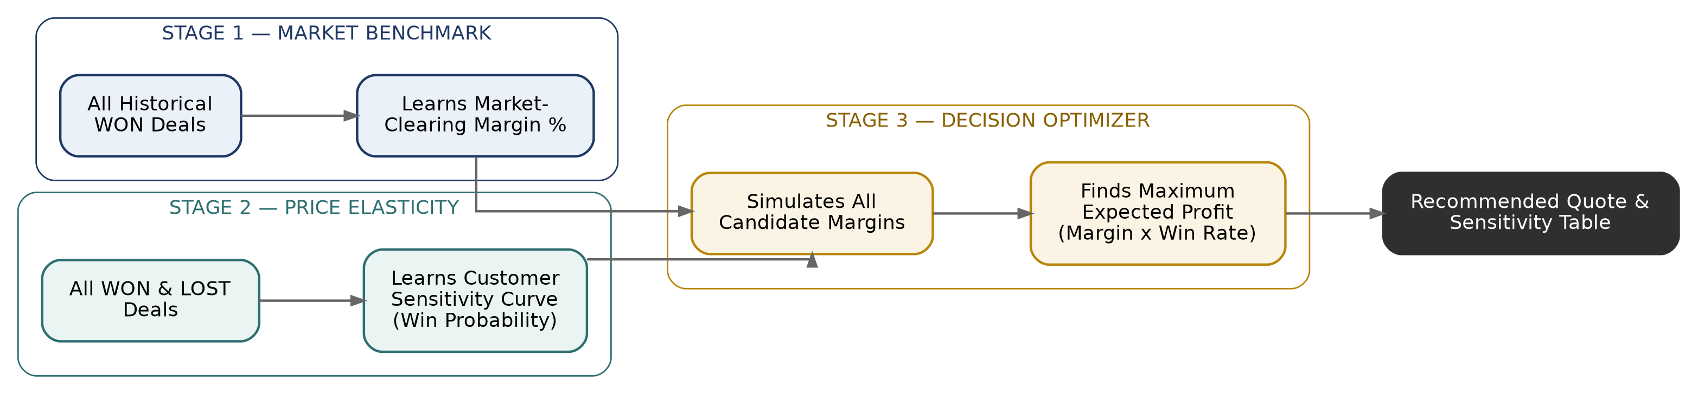
Figure 1. The three-stage flow from historical deals to a recommended quote.

Stage 1: Finding the Market Benchmark
The question it solves: for this lane, weight bracket, and cargo type, what margin do winning deals normally close at in the open market?
How it works: we train a regressor exclusively on past won deals. It analyzes all shipment features, cost, weight, route, and commodity, and predicts the fair market clearing margin, for example 15.2%.

Stage 2: Understanding Customer Price Elasticity
The question it solves: if we quote above or below that market benchmark, what is the realistic chance the customer says yes?
How it works: we train a classifier on both won and lost inquiries. It learns how customers react to different markups.
- Economic reality rule: the model enforces a strict common-sense rule. As our quote becomes more expensive relative to the market benchmark, the win probability must strictly go down. The model cannot pretend that a higher price increases the win rate.
- Calibration: we calibrated the probabilities so that if the engine says a quote has an 80% win probability, roughly eight out of ten similar real-world quotes actually convert to wins.

4. The Weightage Assigned to Each Input
When calculating a quote, not all inputs carry equal weight. Here is the plain-English breakdown of how much influence each factor has.
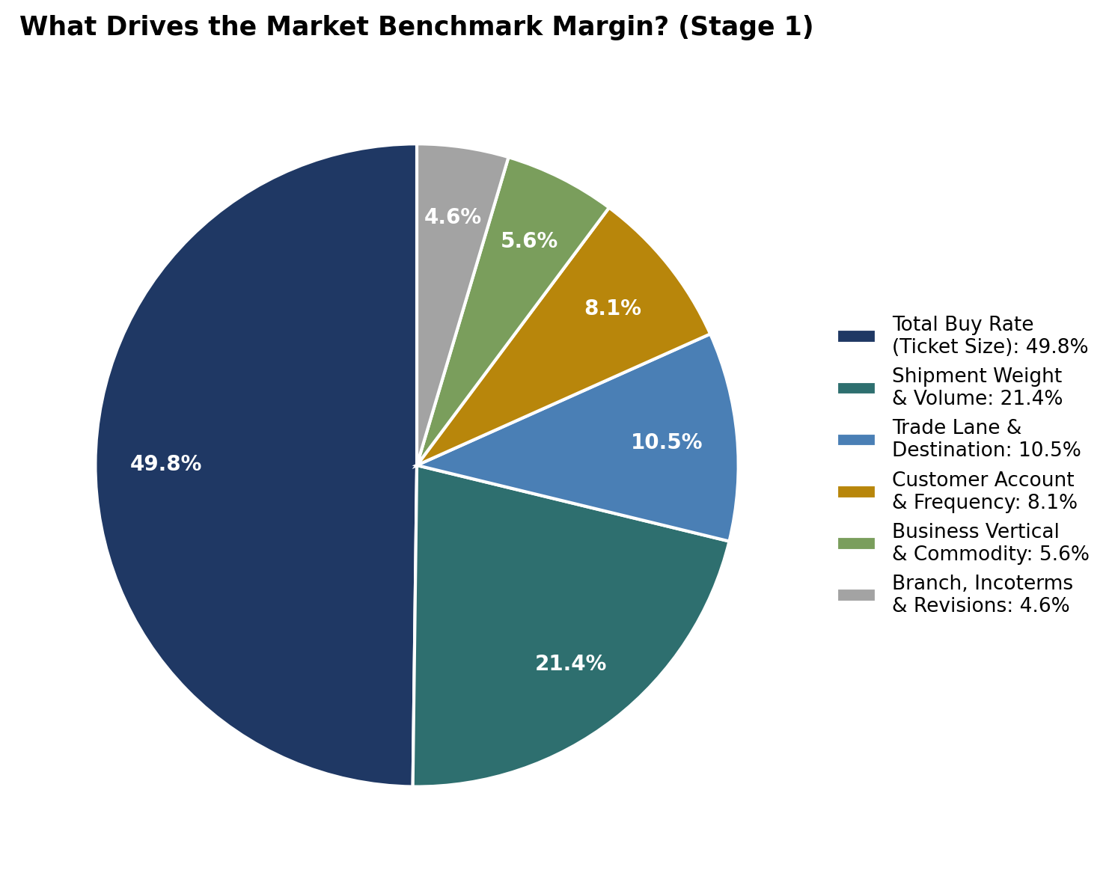
Figure 2. Relative influence of each factor on the Stage 1 market benchmark margin.

1. Total Buy Rate (Cost Anchor): about 50% weight
This is the single biggest driver. Air freight margins follow an inverse sliding scale.
- On a 10,000 INR shipment, a 30% margin is standard and accepted by shippers, adding 3,000 INR.
- On a 500,000 INR shipment, a 30% margin would add an unacceptable 150,000 INR markup. Market reality forces large shipments into tighter 5% to 15% margins.

2. Weight, Density & Volume: about 21% weight
- Heavy bulk cargo above 1,000kg triggers lower percentage markups due to airline volume rates and intense forwarder competition.
- Small courier parcels under 45kg carry higher percentage markups because baseline operational handling costs are higher per kilogram.

3. Trade Lane & Destination: about 11% weight
- High-volume, highly competitive trunk routes, such as Mumbai to Dubai or Frankfurt, have thinner margins.
- Secondary or long-haul destinations with limited carrier space, such as South America or Africa, command higher margins.

4. Customer Relationship & Frequency: about 8% weight
- Frequent repeat shippers, our Key Accounts, receive competitive pricing to retain high annual freight volume.
- Spot or one-off subagents receive standard commercial markups.

5. Business Vertical & Branch Execution: about 10% combined weight
- Express Courier and Air Perishables command higher margins due to time criticality.
- Branch origin reflects local carrier procurement agreements and regional market conditions.

5. How the Engine Recommends the Margin
Once the engine knows the Market Benchmark from Stage 1 and the Customer Win Probability Curve from Stage 2, it uses the following logic to pick the final number.

A. The Expected Profit Formula: The Sweet Spot
The engine does not simply quote the highest margin, nor does it blindly slash prices to win every deal. Instead, it maximizes expected value, the total expected rupee profit:
Expected Profit = Margin Amount (Rs.) x Probability of Winning
Here is a simple real-world comparison for a 100,000 INR shipment:
Strategy | Quoted Margin | Quoted Profit | Win Probability | Expected Rupee Profit | Outcome Assessment
Price Slasher | 5% | Rs. 5,000 | 95% | Rs. 4,750 | We win easily, but leave money on the table.
Engine Sweet Spot | 18% | Rs. 18,000 | 70% | Rs. 12,600 | Optimal. Produces the highest overall profit.
Greedy Skimmer | 40% | Rs. 40,000 | 10% | Rs. 4,000 | Large profit on paper, but we almost always lose the deal.
The engine automatically selects the margin that yields the 12,600 INR sweet spot.

B. The Key Account Retention Safeguard
One of the most important rules built into the engine is Account Retention Protection.
- In B2B freight forwarding, losing a Key Account who ships thirty times a year because of one greedy quote is a disaster for company revenue.
- Whenever the customer has high transaction frequency (Customer Inquiry Frequency greater than 15), the engine automatically dampens extreme margins.
- Even if the mathematical optimizer sees a tempting one-time profit at a 25% margin, the retention safeguard caps and penalizes excessive markups, protecting the long-term customer relationship while keeping the quote highly profitable.

C. The Margin Sensitivity Table: Full Visibility for Sales Reps
The engine does not force sales reps into a black box. In the results panel, it generates a complete Margin Sensitivity Table.
Margin % | Quoted Sell Rate | Gross Margin (Rs.) | Win Probability | Expected Value
10.0% | Rs. 110,000 | Rs. 10,000 | 92% | Rs. 9,200
15.0% | Rs. 115,000 | Rs. 15,000 | 84% | Rs. 12,600
19.1% (recommended) | Rs. 119,100 | Rs. 19,100 | 72% | Rs. 13,752
25.0% | Rs. 125,000 | Rs. 25,000 | 45% | Rs. 11,250
30.0% | Rs. 130,000 | Rs. 30,000 | 22% | Rs. 6,600
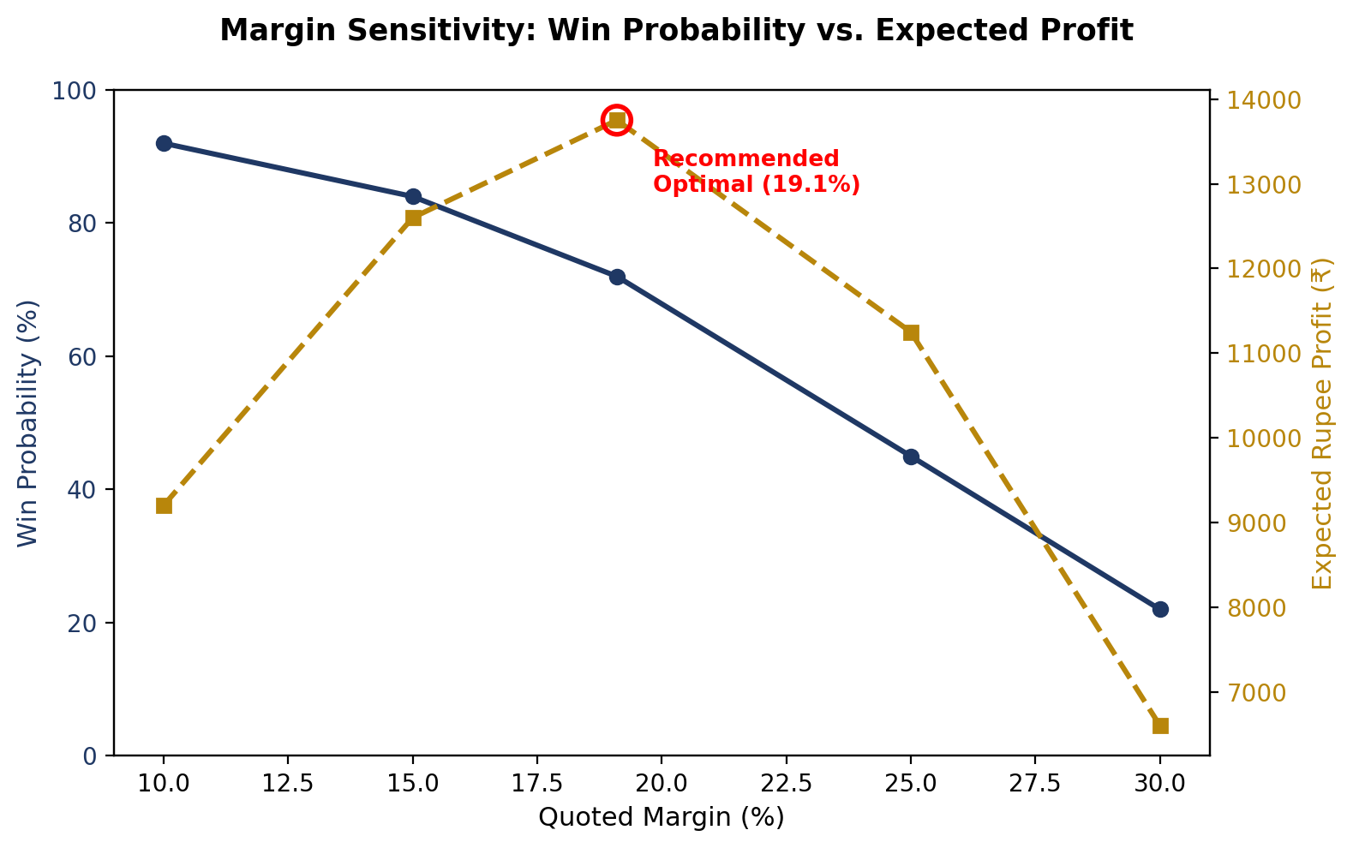
Figure 3. As the quoted margin rises, win probability falls while expected profit peaks near 19.1%.
- If the sales rep needs volume: the table shows that lowering the margin from 19.1% to 15.0% raises the win rate from 72% to 84%.
- If capacity is constrained during peak season: the rep can quote 25.0% and still maintain a 45% win chance.

6. Summary Checklist for Sales & Pricing Teams
- Enter accurate shipment details: correct cargo dimensions and gross weight ensure the engine accurately determines volumetric versus dense cargo breaks.
- Select the correct Customer Type and Frequency: identifying a Key Account ensures the system protects long-term customer loyalty.
- Use the Recommended Margin as your primary guide: it represents the single most profitable rate balance backed by historical data.
- Leverage the Sensitivity Table for negotiation flexibility: use the win-rate percentages when negotiating live on the phone with shippers.

